WI-UM Key Club District
Social Media Banner Patch

Technology is a big part of modern life, and Key Club shouldn’t be left out of the loop when it comes to the latest trends! If your club’s social media game is strong, then this banner patch is the perfect way to recognize your club’s social media outreach which helps you connect with your members!

Qualifications for the Social Media Banner Patch

- Your club must have an updated club website, Facebook page, and either a Twitter or Instagram account.
- Your club must follow either the WIUM Twitter or Instagram account @wiumkeyclub.
- Your club must post pictures and/or statuses related to 6 of the 8 topics listed below. Tag the WIUM account on the social media platform that you use to post the picture and/or status.
Topics:
- District Project (Camp Wawbeek or Baycliff Health Camp)
- K-Family (Kiwanis, Circle-K, K-Kids, etc.)
- Preferred Charities
- DCON Planning (Making decorations, costumes, etc.)
- Going to a Divisional Council Meeting
- Working with another Key Club
- Submitting a Monthly Report Form
- Celebrating Key Club Week (November 7-11, 2016)

- Attach screenshots of each post made on your club’s social media accounts that relates to the topics above.
- Obtain the signature of your Key Club Faculty Advisor. This signifies that the information provided is accurate.
- Submit the award patch application form below no later than January 20th, 2017 to the District Administrator, Kathy Gillis, at wium.admin@gmail.com.

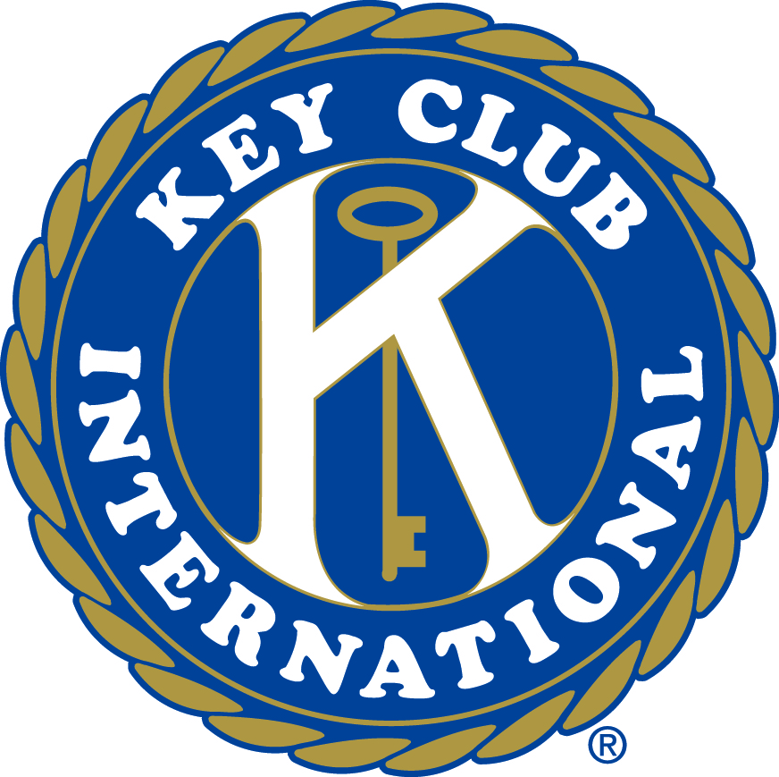

WI-UM Key Club District
Divisional Teamwork Banner Patch Application
Please scan in and email the following information to wium.admin@gmail.com

Key Club/School:

Faculty Advisor:

High School’s Address:

City: State: Zip:

Twitter and/or Instagram Handle:

Faculty Advisor Signature: _____________________________________________

___________________________________________________________

Reflection
Please write a paragraph which answers the following question:
How does social media and technology make Key Club more successful?

