WI-UM Key Club District
Preferred Charities Banner Patch

There are four Preferred Charities that the Wisconsin-Upper Michigan District supports, and they are: UNICEF, March of Dimes, Yell & Tell, and the Children’s Miracle Network. These are all great organizations that benefit Kiwanis’ mission of serving the kids of the world. This banner patch recognizes the great work that clubs do with our Preferred Charities and their impact on the lives of children all around the world.

Qualifications for the Preferred Charities Banner Patch

- Your club must hold two service projects that benefit two of the four Preferred Charities listed above.
- Obtain the signature of your Key Club Faculty Advisor. This signifies that the information provided is accurate.
- Write a detailed paragraph describing how you benefited our Preferred Charities and the impact that it had on your school and community.
- Submit the award patch application form below no later than January 20th, 2017 to the District Administrator, Kathy Gillis, at wium.admin@gmail.com.
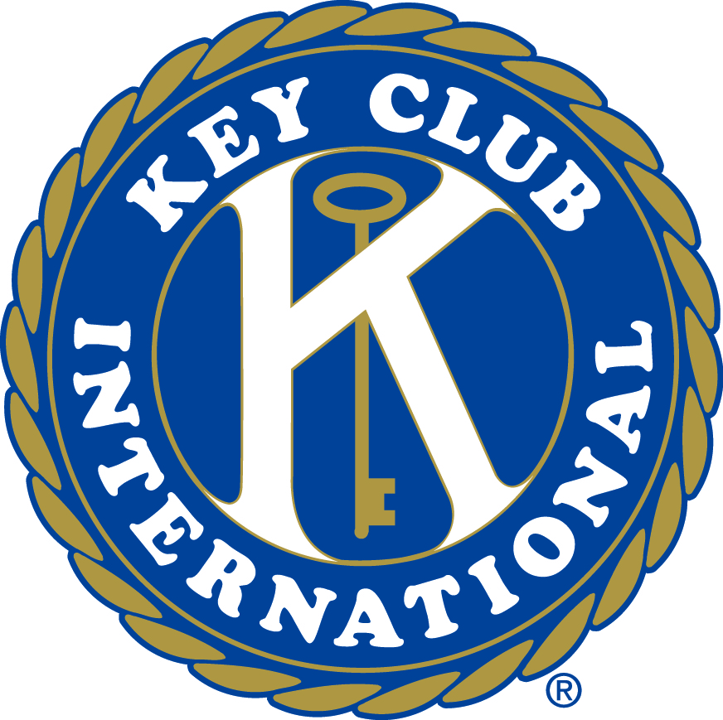

WI-UM Key Club District
Preferred Charities Banner Patch Application
Please scan in and email the following information to wium.admin@gmail.com

Key Club/School:

Faculty Advisor:

High School’s Address:

City: State: Zip:

Name of Service Project:
Date of Completion:
Preferred Charity Benefited:
Number of Service Hours Completed:

Name of Service Project:
Date of Completion:
Preferred Charity Benefited:
Number of Service Hours Completed:

Faculty Advisor Signature: _____________________________________________

___________________________________________________________

Reflection
Please write a paragraph describing the service projects your club completed, how they helped the preferred charities, and the importance of the charities that you helped.

