WI-UM Key Club District
Divisional Teamwork Banner Patch

Key Clubs often work together within their divisions to create some truly wonderful service projects. But why stop there? There are 17 divisions in the Wisconsin-Upper Michigan District that your club can work with to make an impact on a larger scale. This banner patch recognizes clubs that work with a club from a different division. As the old saying goes, “the more, the merrier!”

Qualifications for the Divisional Teamwork Banner Patch

- Your club must hold a service project with a club from a different division.
- Obtain the signature of your Key Club Faculty Advisor. This signifies that the information provided is accurate.
- Write a detailed paragraph describing the service project that your club held with a club from a different division and the impact that it had on your community.
- Submit the award patch application form below no later than January 20th, 2017 to the District Administrator, Kathy Gillis, at wium.admin@gmail.com.
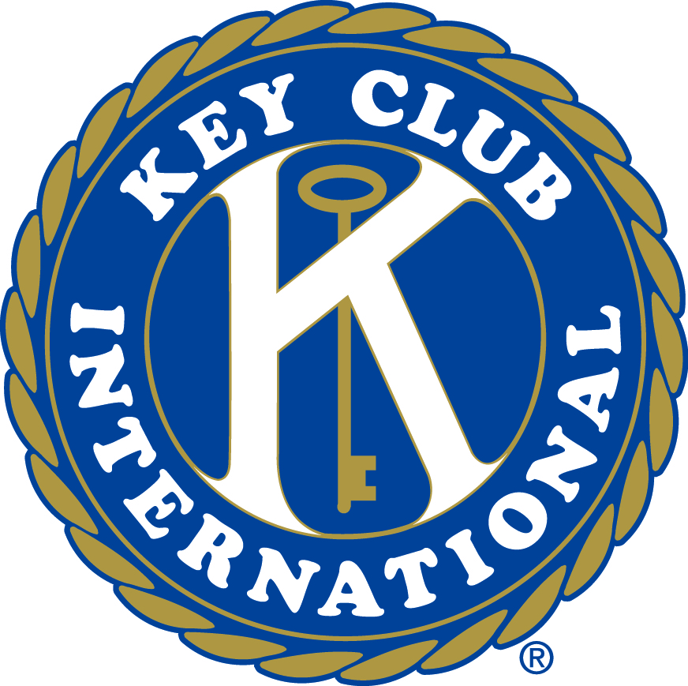

WI-UM Key Club District
Divisional Teamwork Banner Patch Application
Please scan in and email the following information to wium.admin@gmail.com

Key Club/School:

Faculty Advisor:

High School’s Address:

City: State: Zip:

Name of Service Project:
Name of your Partnering Key Club:
Division of the Partnering Key Club:
Their Faculty Advisor:
Number of Key Clubbers Attended from Both Clubs:
Number of Service Hours Completed:

Faculty Advisor Signature: _____________________________________________

___________________________________________________________

Reflection
Please write a paragraph which answers two of the three questions:
1. What were the challenges of working with a club from outside your division?
2. What did your club learn in pairing up with another club?
3. How did pairing up with a club from another division help the success of the project?

